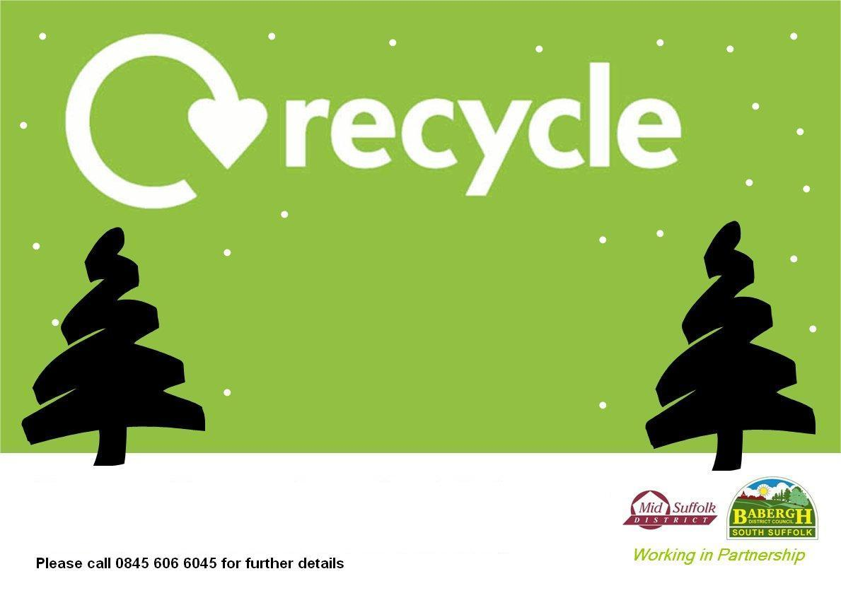

**Trees can be left at this collection point between Saturday 2nd January and Wednesday 6th January.**

**Collection will be made from 6.30am on Thursday 7th January.**

**Trees must be less than 7’ tall & must have all decorations, stands & pots removed. Please call 0300 1234 000 (Option 4) for further details.**

**Your real**

**Christmas tree**

**in Sproughton**

**(on the Village Green)**

